POLITICAL CARTOON CLOSE LOOKING ACTIVITY
Examine the political cartoon from the cover of Judge Magazine (Vol. 7 No. 157) for October 18, 1884. This edition was published three weeks before the 1884 election in which Belva Lockwood was a candidate for president on the Equal Rights Party ticket.

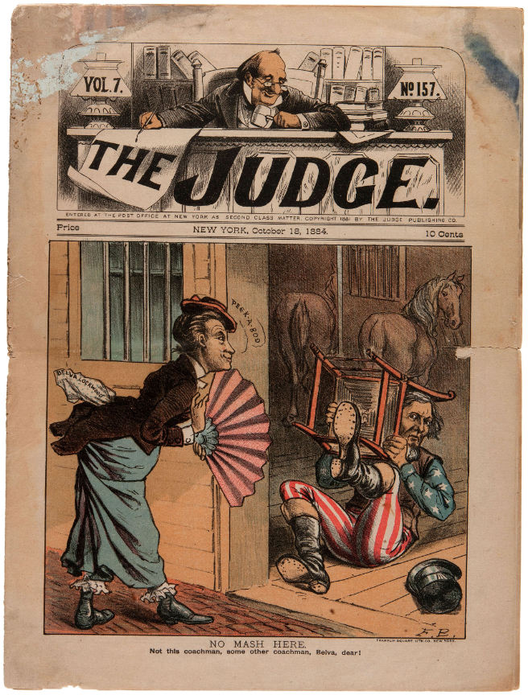
After looking at the cartoon, answer the following questions:

- Who does the figure holding the chair represent? Why might they be in a stable? Who might the “coachman” be that caption is referring to? What is “Mash”?

- Why do you think Lockwood is saying “Peek-A-Boo” to the figure holding the chair? Why might the figure be fearful of Lockwood?

- The man at the top of the picture is “The Judge.” Who might he represent? What might he be judging?

